This document provides student instructions for the additional excel exercises. The relevant spreadsheets are located in the accompanying folder. These exercises start from Module 2.

Module 2 – Add
ABC Company has a large Sales team which sometimes need to borrow laptops or mobile/cell phones for travel to client sites. It is your job to keep track of these items in a basic inventory.
Use the ADD formula in the Inventory spreadsheet provided to work out the total number of each category of mobile phone and laptop. You can use any of the methods shown in Module 2.
Once you have done this, add some text under the main inventory saying ‘Summary of items’, and add the following in a list:
- Apple Phones
- Android Phones
- Grand total phones
- Apple Mac laptops
- Windows laptops (any laptop not named ‘MacBook’ is assumed to be Windows)
- Grand total laptops
It is up to you exactly how you present it, but here is a suggestion:
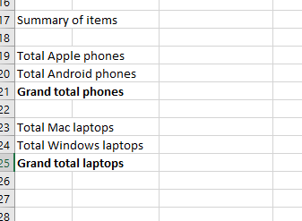

Now, using the figures in the main inventory, calculate the summaries for each category of phone and laptop, and grand totals, using the ADD formula.

Please save this spreadsheet once you have completed this exercise, as you will be using it again to practice other formulas in a later module.

Module 3 – Multiply
ABC Company management like to keep a careful eye on their Sales team’s performance. It is your job to keep track of the number of sales made each month by each salesperson, and how much profit this corresponds to.
Open the Sales spreadsheet provided. You will see a table with the sales figures for each salesperson, broken down by month. This currently just shows the amount of sales, not their value.
Use what you learnt in Module 2 (ADD) to work out the total sales figures for each salesperson, in the Total column:

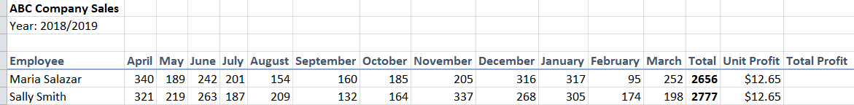

Next, use your new knowledge from Module 3 to work out the total profit made by each salesperson. To do this, you should multiply the figures from column N (Total) by the Unit Profit value in column O. Show the total profit in column P (Total Profit):

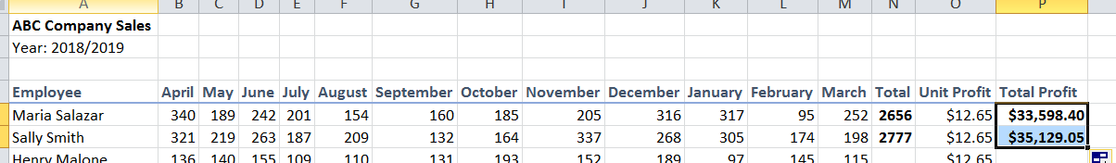

Please save this spreadsheet once you have completed this exercise, as you will be using it again to practice other formulas in a later module.

Module 4 – Subtraction
Bill keeps a spreadsheet with all of his income and expenditure recorded to help him to budget.
Open the Budget spreadsheet provided. You can see he has added details of his wages and things like rent which he needs to pay for each month. Finish the spreadsheet to work out the following:
1. ADD up his total monthly expenditure.
2. Use what you have learned in this module about subtraction to work out how much disposable income he has every month (subtract total expenditure from total income).

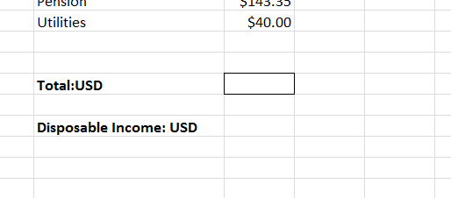
Bill’s sister is having a spring clean and has a lot of old kids’ stuff she wants to get rid of. She has asked Bill to help her work out if it’s worth selling online or if she should just donate it all to charity/thrift.
Bill adds the items into his spreadsheet and estimates how much they might sell for and what the associated fees are likely to be. Open the ‘Spring Clean’ worksheet in the Budget spreadsheet to see his work.
Use your knowledge of subtraction in Excel to work out how much profit they might make on each item (subtract fees from value). You can also use the ADD function to work out the total profit for all items. Do you think it’s worth going to the trouble of selling them?

Please save this spreadsheet once you have completed this exercise, as you will be using it again to practice other formulas in a later module.

Module 5 – Division

Despite keeping a budget spreadsheet, Bill finds that he keeps overspending every month. He decides it would be useful to work out exactly how much spare cash he has every week / day so he can better manage his daily spending.
Open the Budget spreadsheet you used in Module 4. To work out how much weekly disposable income Bill has, do the following calculations:
1. Multiply his monthly disposable income by 12, to find out how much he has for the year.
2. Divide this figure by 52 to find out how much he has per week.
3. Divide the weekly figure by 7 to figure out what his daily disposable income is.

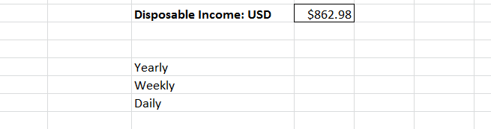

He also considers looking for somewhere cheaper to rent. He has seen a place advertised for $235 per week. Use what you have learned to figure out if this is less than what he is already paying.
1. Multiply his current rent by 12 to work out the yearly amount.
2. Divide this figure by 52 to work out the weekly rent.

Would Bill be better off if he took the new apartment?

Please save this spreadsheet once you have completed this exercise, as you will be using it again to practice other formulas in a later module.

Module 6 – Sort
Open the Sales spreadsheet you used in Module 3.
Managers in ABC Company want to know which salespeople performed the best in the financial year 2018-2019, so they can be awarded bonuses. The criterion for a bonus is either to have been top salesperson in two or more months, or to have the most overall sales for the year.
They also want to know if there are any salespeople who appear to be struggling and may need extra training & support. The criterion for this is to have the lowest sales in two or more months.

To work this out, sort the data for each month in turn, and take a note of the people with the highest and lowest sales figures. Add this information into the spreadsheet like this:

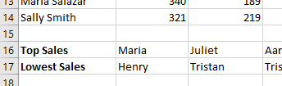

Also sort the data in the Total column to find out who had the most sales overall for the year.

Based on your calculations, who should receive a bonus? Who needs more training?

Please save this spreadsheet once you have completed this exercise, as you will be using it again to practice other formulas in a later module.

Module 7 – Percentages
Open the Inventory spreadsheet, which you used in Module 2.
Your manager wants to know how many items are out of use because they are broken, and they would like the figures expressed as percentages.
Add a new column next to the Total column called % Broken. Use the percentage function to work out what percentage of each category of mobile phone and laptop is broken (i.e. ‘Out for repair’).
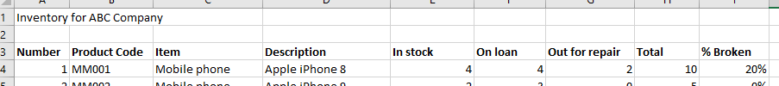

You can also try this, to see the data as a summary:
- Add up the total amount of all phones and laptops
- Add up the total amount of broken / ‘out for repair’ phones and laptops
- Work out the overall percentage of broken items from these two figures

Your manager also wants to know the split between Apple vs Android phones, and Apple Mac vs Windows laptops. Use the summary figures you calculated in Module 2 to work out the following:
- Percentage of phones which are Apple iPhones
- Percentage of phones which are Android
These should add up to 100%.
- Percentage of laptops which are Apple MacBooks
- Percentage of laptops which are Windows
Again, these 2 percentages should add up to 100%.

Please save this spreadsheet once you have completed this exercise, as you will be using it again to practice other formulas in a later module.

Module 8 – Running Totals

ABC Company has a requirement to keep track of their Sales team’s mobile data usage. It is part of a general drive to encourage staff to make use of home wireless, mobile hotspots and other free connection options.
Open the Inventory spreadsheet you used in the last module. Select the ‘Data Usage’ worksheet.
Data is recorded for the last 30 months or so, showing data usage per month for the entire Sales team. Use what you have learned in this module to work out the running totals.
Note: please work out separate running totals for each year, i.e. after working out the totals for 2017 please start a new running total for the months in 2018, and another for 2019.

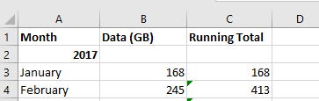

Compare the running total in September each year. Does it look as if data usage has increased or decreased so far in 2019?

Please save this spreadsheet once you have completed this exercise, as you will be using it again to practice other formulas in a later module.

Module 9 – Print

You are preparing for a meeting with your manager. You know she will want to discuss the latest sales data and take a paper copy of the figures / her notes away with her.
Open the Print spreadsheet provided.
Please note, if you do not have access to a printer, or you would prefer not to print unnecessarily, you can still complete these exercises by choosing the Microsoft Print to PDF option instead of a physical printer.

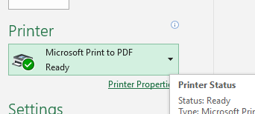

Use what you have learned in this module to print using the following different options:
1. Print the entire workbook
2. Select the ‘Visual Data’ worksheet. Print only this worksheet.
3. On the ‘Sales Orders’ worksheet, select and print only the data relating to the region ‘Central’ (the first 25 rows).

Please save this spreadsheet once you have completed this exercise, as you will be using it again to practice other formulas in a later module.

Module 10 – Paste Special
ABC Company management are reviewing Sales figures. This time they want to see figures for each month.
Open the Sales spreadsheet you saved in Module 6. You will be taking some of the data from the table of sales data, and putting it into the ‘2018-19 By Month ‘worksheet, using Paste Special.
First of all, please use your general Excel knowledge to work out the total sales figure for each month – add a total at the bottom of each column.
Next let’s copy and paste the required data into the ‘2018-19 By Month’ worksheet. All you want to show is the month, and the total sales for each. You don’t want the salespeople’s names or a breakdown of their individual sales.
To do this, highlight the names of the months:
Copy this data. Now go into the ‘2018-19 By Month’ worksheet, select a cell and right-click. Choose Paste Special from the menu which appears.
Choose Values and Transpose and then click OK. The month names should be pasted into a column.
Repeat this exercise with the totals you worked out earlier. Highlight and copy the cells:
Then go to the other worksheet, and Paste Special using the same options as before. Make sure you select the cell next to the one with April in it, so that the correct monthly sales figures are pasted in next to the names of the months.
You should now have 2 rows, showing the total sales for each month.

Please save this spreadsheet once you have completed this exercise, as you will be using it again to practice other formulas in a later module.

Module 11 – Merge

Open the Inventory spreadsheet you last used in Module 8. Go to the ‘Data Usage’ worksheet.
As you can see, the headings for each year are not particularly clear – this could be improved on. For each year, Merge & Center the cells. For example, for 2017, select cells A2, B2 and C2, and then choose Merge & Center.

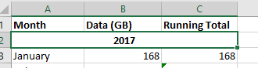

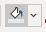
Experiment with other ways to make the headings look more obvious. For example, you could underline the text, or add some color (using the paint pot icon in the Font section).

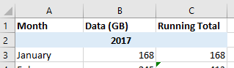

Please save this spreadsheet once you have completed this exercise, as you will be using it again to practice other formulas in a later module.

Module 12 – Filter

Open the Print spreadsheet you used in Module 9 and choose the ‘Sales Orders’ worksheet.
Use what you have learned in this module to filter the data as follows:

1. Filter by Region and select only the West region.
2. Apply another filter – this time a number filter. For the Total column, choose to filter on numbers greater than 456.
Your results should show the sales results for only 2 reps.
456 is the mean average sales figure, so this filter shows you which sales reps are performing above average in the West region.

3. To see which sales reps are performing above average across all regions, clear the filter on the Region column.
4. Color the names of all the sales reps. You may choose which color to use; we have used green.
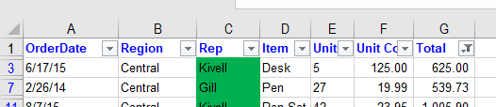
5. Clear the filter on the Total column to once again see all the sales figures.

You can now see at a glance who the top performing sales reps across all regions are.

6. Finally, sort the Total column from Largest to Smallest.

Please save this spreadsheet once you have completed this exercise, as you will be using it again to practice other formulas in a later module.

Module 13 – AVERAGE

ABC Company management want to look at average sales figures for key months, and key salespeople.
Open the Sales spreadsheet, which you last used in Module 10. Select the ‘2018-19 By Employee’ worksheet.
Add some new text – one list item per line:
- Average Sales April
- Average Sales December
- Average Sales April Henry and Tristan
- Average Sales April Aaron and Fergus
Then use what you have learned in this module to work out each of the averages.
Tip: you will be able to use a range for the first four averages – for example, =AVERAGE(B5:B14). For the last two averages, you will need to select individual cells – for example, =AVERAGE(B12,B10).
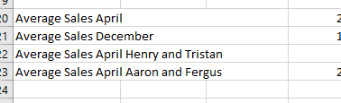

Please save this spreadsheet once you have completed this exercise, as you will be using it again to practice other formulas in a later module.

Module 14 – AVERAGEIF

Open the Print spreadsheet you used in Module 12 and choose the ‘Sales Orders’ worksheet.
Add some text to say ‘Average’ into a blank cell.
Use what you learned in Module 13 to work out the AVERAGE of all the Total sales figures. (Tip: calculate the average of the range G2 to G44.)
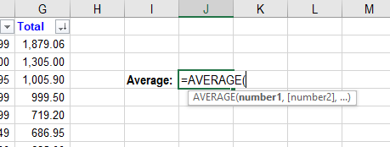

Below this, use the AVERAGEIF formula in the same way as in the video you just watched. Use what you have learned in this module to find out what the average is for each salesperson. For example:
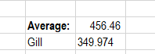
Enter each salesperson’s name in turn to see their average sales. You can compare their individual average with the overall average you calculated. Who has the highest average sales? Who is under-performing?
There is more you can do with this data. For example, you can work out how many units of each item were sold on average, or what the average revenue is for each item:
1. Use an AVERAGEIF formula where the range is the Item column, the criteria is an item’s name, and the average_range is the Units column.
2. Use an AVERAGEIF formula where the range is the Item column, the criteria is an item’s name, and the average_range is the Total column.
These are just some suggestions. Try finding out different averages based on different criteria.

Please save this spreadsheet once you have completed this exercise, as you will be using it again to practice other formulas in a later module.
Module 15 – SUMIF

Open the Print spreadsheet you used in the last module and choose the ‘Sales Orders’ worksheet.
Ensure you remove any filters on the data (for example, we filtered on the Region column in Module 14).
Add some text to say SUMIF into a blank cell. Underneath this, add text for these different values:
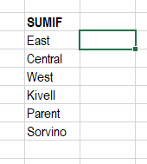
You will be using the SUMIF formula to work out the number of units sold for each category. The first three are Regions, and the last three are Reps.

Using the SUMIF formula, calculate the number of units sold in the East region. To do this:
1. Choose the data in the Region column for the range.
2. For the criteria, either choose a cell where it says East, or type in “East” as the criteria.
3. Choose the data in the Units column for the sum_range.
Your formula should be something like this: =SUMIF(B2:B44,B13,E2:E44)

Repeat this exercise for the other five categories. Please note that when you move onto the last three you will need to select the data in the Rep column as the range, and either type the relevant name in or select a relevant cell for the criteria.

Please save this spreadsheet once you have completed this exercise, as you will be using it again to practice other formulas in a later module.

Module 16 – IF

Open the Budget spreadsheet you last used in Module 5.
Bill wants to see easily if he is under or over budget, especially when he adds new expenses in.
Add a new column header saying Within Budget:
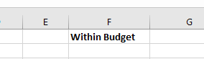

Underneath, use what you have learned in this module to enter an IF formula to calculate if Bill is within budget or not. Your formula should check whether the value of his income (cell B3) is larger than his expenditure (cell D15). Is he currently within his budget?
Bill has some potential extra expense this month - he would like to buy a new iPad for $969. Try adding this figure in to the bottom of his list of expenses and see whether this changes the result of your IF calculation.
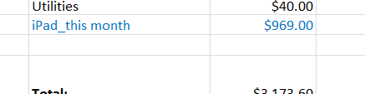

Would this put him over budget for the month?
Delete the text / number you just added for the iPad to leave only his actual expenses.

Please save this spreadsheet once you have completed this exercise, as you will be using it again to practice other formulas in a later module.

Module 17 – VLOOKUP
Open the Suppliers spreadsheet which has been provided.
ABC Company have a spreadsheet with details of the main contacts at each of their suppliers. The person who maintains the spreadsheet has come to you because they need an easy way of finding out company names from the codes which show up in Finance reports.
Use what you have learned in this module to perform a VLOOKUP, as follows:
- Enter your VLOOKUP formula into cell B4 on the Query worksheet.
- Use cell B3 as the lookup_value. You will enter Finance codes in this cell later to find company names.
- Use the entire table on the Contacts worksheet as the table_array.
- You are looking for the Company name – which column should you specify for the column_index_num?
- You can choose if you want to use an exact or approximate match
When you have finished this formula, you will get an #N/A error. Don’t worry – this is because there is currently no value in cell B3.
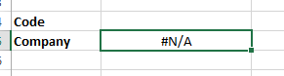
The current Finance report mentions the following 5 company codes. Enter them into cell B3 one at a time to determine the company they relate to:
- 537487-4088
- 983515-5194
- 548136-8818
- 978459-3247
- 836921-3718

Please save this spreadsheet once you have completed this exercise, as you will be using it again to practice other formulas in a later module.

Module 18 – HLOOKUP

ABC Company offer regular training sessions to their staff, which are held in several locations. The training sessions are all set up for the first part of the year, and most dates have been agreed.
In order for line managers to be able to plan rotas or holidays while certain staff are being trained, they need to be able to easily check the relevant dates for each staff member.
Open the Training spreadsheet which has been provided. It contains a list of staff, their department and the Center where they will receive their training. It also has a separate ‘Dates’ table where the training date for each Center has been noted, and a ‘Quick Lookup’ tool.
Do an HLOOKUP in cell D2 to take the dates from the ‘Dates’ table. Use these criteria:
- Lookup_value is the name of the training Center. Use a cell reference rather than typing the name. For example, for row 2 you would use C2.
- Table_array is the entire ‘Dates’ table. (remember to insert dollar signs ($) so that the value is fixed – this can be done by pressing F4 after selecting the table array (this may not work on some keyboards/devices) or inserting the dollar signs manually).*
- Row_index_num is the row containing the dates.
- You can set the range_lookup as either true or false.
This should return a value from the ‘Dates’ table. You can then click and drag the formula down the entire column to fill in the dates for all members of staff.
Next, to further help the line managers, complete the ‘Quick Lookup’ tool where they can enter someone’s name and return their training date straight away.
This time, you will need to use VLOOKUP, as you did in the last module.
- Do a VLOOKUP in cell G11, using these criteria:
- Lookup_value is cell G10, where you will enter the staff member’s names.
- Table_array is the entire table of names/departments/locations/dates.
- Col_index_number is the column containing dates.
- Range_lookup can be either true or false, but think carefully about what which option will make a quick search easiest.
When you have finished this formula, you will get an #N/A error. Don’t worry – this is because there is currently no value in cell G10.
Enter a name into cell G10. Please note that if you have set the range_lookup to FALSE (ie needs an exact match), then you will need to enter the full name exactly as it is shown in the table.
Finally, the date for the Dublin training has now been agreed as 16/03/2020. Please enter this date into the ‘Dates’ table. You should now see the date being updated across the main table.

Please save this spreadsheet once you have completed this exercise, as you will be using it again to practice other formulas in a later module.

Module 19 – COUNTIF

ABC Company management want to see further detail on how their sales force are performing. They want to offer rewards to top performers and further training to those who aren’t doing so well.
Open the Sales spreadsheet you used in Module 13 and select the ‘2018-19 by Employee’ worksheet.

Add 2 column headings at the end of the table: Months Top and Months Bottom:
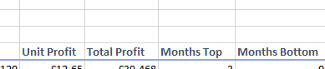

Use the COUNTIF formula to determine how many times each salesperson has been top and bottom of the monthly sales figures tables. Use the Top Sales and Lowest Sales results you got in Module 6:

Start with the Months Top column, and do a COUNTIF formula for each salesperson. Here’s an example for Aaron:
=COUNTIF(B17:M17,M17), where B17: M17 is the range and M17 is the criteria. For the criteria you could write “Aaron” instead of using the cell reference.
Then move to the Months Bottom column, and repeat the exercise, this time using B18:M18 as the range.
Management have determined that anyone who had the top sales figures for more than 2 months over the year should be awarded a bonus. Who is entitled to a bonus?
Anyone who has had the lowest sales figures for more than 2 months over the year will be offered more training. Who is going back to school?

Please save this spreadsheet once you have completed this exercise, as you will be using it again to practice other formulas in a later module.

Module 20 – COUNTBLANK

ABC Company take training very seriously. They aim to deliver training continuously to their staff, both refresher courses and courses aimed at new members of staff.
They have planned the training for the coming year. Open the Training spreadsheet you last used in Module 18. Go to the ‘Planned’ tab.
There are 48 training slots available throughout the year, 12 for each quarter. The sessions currently agreed are marked in the table.

Generally, the company like to fill up at least half of the training slots to ensure they are making good on their commitment to continuous training.
Do a quick COUNTBLANK formula in cell B16 to see how many training slots are left.
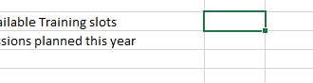
Have the company met their goal?

Please save this spreadsheet once you have completed this exercise, as you will be using it again to practice other formulas in a later module.

Module 21 – COUNTA

Continuing on the examination of training sessions from the last module, open the Training spreadsheet, and go to the ‘Planned’ tab.
Do a COUNTA formula in cell B17 to count how many training sessions are being offered this year.
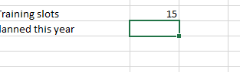
This figure plus the figure above should add up to 48.

There have been some changes to training sessions. Please update the table to reflect the following:
- Sales Techniques has been extended to a session every quarter
- Mindfulness has been cancelled entirely
- A Diversity training session has been agreed for Q4
- Fire Safety sessions have been added in Q2 and Q4

Please save this spreadsheet once you have completed this exercise, as you will be using it again to practice other formulas in a later module.

Module 22 – COUNT

One of the Sales team keeps a spreadsheet of her key customers. She likes to keep a record of when she has contacted them, and when they have responded, to ensure she doesn’t annoy them by bombarding them with emails or calls.
Her personal target is to maintain regular contact with at least 80% of her key customers. She has asked you how she can easily keep track of this.
Open the Customers spreadsheet which has been provided.
Use what you have learned in this module to add a COUNT formula, to calculate how many cells in the Responded column contain numeric data.

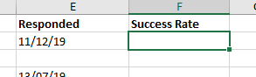

Is the Salesperson hitting her target?

Please save this spreadsheet once you have completed this exercise, as you will be using it again to practice other formulas in a later module.

Module 23 – CONCATENATE

Please open the Suppliers spreadsheet which you last used in Module 17.
ABC Company have a spreadsheet with details of the main contacts at each of their suppliers. The person who maintains the spreadsheet has come to you because they need the names in the format ‘Firstname Lastname’ and ‘Lastname, Firstname’. They don’t want to make changes manually because there are almost 100 names in total and it would take too long. Can you help?
Use what you have learned about the CONCATENATE formula to populate the Firstname Lastname column and the Lastname, Firstname column with names in the correct format.
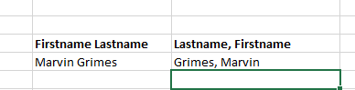

Don’t forget to add text for any spaces or commas required.
TIP: Once you have done the formula for the first name, you can click and drag the formula down the rest of the column:
- Click on the cell you have just entered the formula into
- Hover the mouse over the small blue square in the bottom right-hand corner of the cell until it looks like a cross (+)
- Click on the blue square and hold down the mouse button as you drag it all the way to the bottom of the list
- When you release the mouse button, the entire list will be populated with the formula and corresponding value

Please save this spreadsheet once you have completed this exercise, as you will be using it again to practice other formulas in a later module.

Module 24 – Transpose

Please open the Training spreadsheet you used in Module 21 and select the ‘Planned’ tab.
The training providers would like to know how many attendees they will have for each course, and for each quarter / session. There is currently nowhere to record these figures easily.
Use TRANSPOSE to copy and paste the list of course titles into another place on this worksheet. You may use either method.
You may need to adjust column sizes to see the titles fully.
To the left of the first course title, insert the text Quarter. Underneath this, add Q1-4 in order:
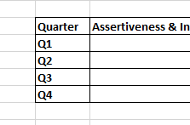
You can also add some borders, as in the example above.
The table is now ready for attendee numbers to be added when they are ready (you don’t need to do this now).

Please save this spreadsheet once you have completed this exercise, as you will be using it again to practice other formulas in a later module.

Module 25 – DATE formula

Please open the Dates and Numbers spreadsheet which has been provided.
Using the DATE formula, convert the numbers in the first table to date format. Do this in the Date formula column.
Change the format so that all the dates are in the dd mmmm yyyy format.

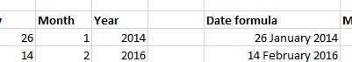

Next, highlight all the data (i.e. from cell A3 to E23). Choose Sort and Filter and then Filter.
Arrange the data from Oldest to Newest.

Please save this spreadsheet once you have completed this exercise, as you will be using it again to practice other formulas in a later module.

Module 26 – MONTH formula

Please open the Dates and Numbers spreadsheet which you last used in Module 25.

Use what you have learned about the MONTH formula to show the month from each date in the Date formula column in the Month formula column.
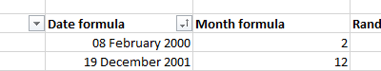

If you have done this correctly, your figures will exactly match the figures in the Month column.

Please save this spreadsheet once you have completed this exercise, as you will be using it again to practice other formulas in a later module.

Module 27 – Pivot Tables

ABC Company management want an easier way to view sales figures from different regions to help them understand the current trends.
Open the Print spreadsheet you last used in Module 15 and select the ‘Sales Orders’ worksheet.
You are going to create a pivot table based on the data in this table. Ensure any filters are cleared before you begin.
Click anywhere on the table and select Insert and then Pivot Table. Use all the default options.
When your pivot table opens, select the following options:
Tick Region, Rep and Units. Drag Region to the Columns area; Rep to Rows; and Units to Values, as shown below.
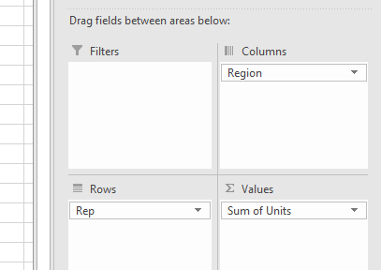
This should give you an easy-to-read breakdown of how the different reps performed in different regions.
Next, untick Rep and tick Item. It should go into the Rows area; if it doesn’t please move it there. This time you have an effective breakdown of how well different items sell in different regions.
Experiment with this powerful tool – try adding / removing other fields; add a filter and use it.

Please save this spreadsheet once you have completed this exercise, as you will be using it again to practice other formulas in a later module.

Module 28 – Pie Charts

Open the Inventory spreadsheet you last used in Module 11 and select the ‘Data Usage’ tab.

A request has been made to display the monthly Data Usage figures in a visual way. Use what you have learned in this module to create a pie chart for the 2017 figures. Don’t include the Running Total column.
Experiment with the chart! Edit the title; change the colors; use a different style.
Trying editing the chart by right-clicking and choosing different options. For example, you could right-click on the chart, choose Add Data Labels and then Add Data Callouts. This would give you this view:
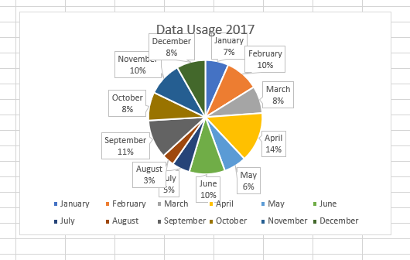
Explore the different options you can use to effectively display the data.

Please save this spreadsheet once you have completed this exercise, as you will be using it again to practice other formulas in a later module.

Chapter 29 – Doughnut Charts

Open the Inventory spreadsheet you last used in Module 28 and select the ‘Data Usage’ tab.

A request has been made to display the monthly Data Usage figures in a visual way. Use what you have learned in this module to create a doughnut chart for the 2018 figures. Don’t include the Running Total column.
Experiment with the chart! Edit the title; change the colors; use a different style.
Explore the different options you can use to effectively display the data.

Compare the doughnut chart you made with the pie chart from the last module. Which is easier to read? Which do you prefer using?

Please save this spreadsheet once you have completed this exercise, as you will be using it again to practice other formulas in a later module.

Module 30 – Line Charts

Open the Inventory spreadsheet you last used in Module 29 and select the ‘Data Usage’ tab.

A request has been made to display the monthly Data Usage figures in a different visual way. Use what you have learned in this module to create a line chart for the 2018 figures. This time, include the Running Total column.
Experiment with the chart! Edit the title; change the colors; use a different style.
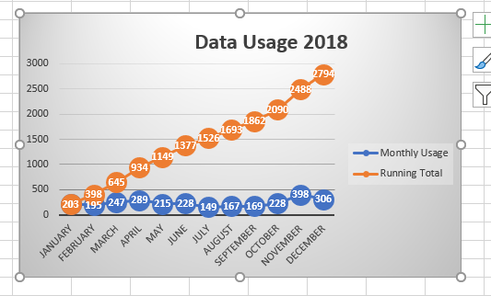
Explore the different options you can use to effectively display the data.
In the example above, we changed the name of each series of data (by default it names them Series 1 and Series 2). To do this, you right-click on the chart and choose Select Data. Click on Series 1 then Edit. Enter the new name and click OK. Repeat for Series 2.
This is just one of many changes you can make. Look through the different options in the Add Chart Element menu. If you don’t like a change you have made, simply press Ctrl – Z to reverse it.

Please save this spreadsheet once you have completed this exercise, as you will be using it again to practice other formulas in a later module.

Module 31 – Column Charts

Open the Inventory spreadsheet you last used in Module 30 and select the ‘Data Usage’ tab.

A request has been made to display the monthly Data Usage figures in a different visual way. Use what you have learned in this module to create a column chart for the 2017 figures. This time, don’t include the Running Total column.
Experiment with the chart! Edit the title; change the colors; use a different style.
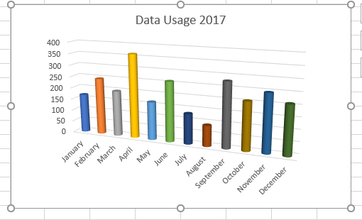
Explore the different options you can use to effectively display the data.
In the example above, we chose a 3D column chart, and changed the shape of the columns to cylindrical and changed the colors.
These are just some of many simple changes you can try, which can make your charts look more appealing. Look through the different options in the Add Chart Element menu. If you don’t like a change you have made, simply press Ctrl – Z to reverse it.

Please save this spreadsheet once you have completed this exercise, as you will be using it again to practice other formulas in a later module.

Module 32 – Bar Charts

Open the Inventory spreadsheet you last used in Module 31 and select the ‘Data Usage’ tab.

A request has been made to display the monthly Data Usage figures in a different visual way. Use what you have learned in this module to create a bar chart for the 2019 figures. Don’t include the Running Total column.
Experiment with the chart! Edit the title; change the colors; use a different style.
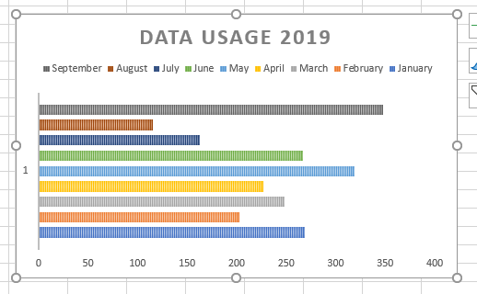
Explore the different options you can use to effectively display the data.
In the example above, we created a standard bar chart, and then chose one of the styles from the Chart Styles bar to change it to something more colorful.

Have a look at all the charts you have made over the last few modules and think about which are the most effective at making the date easy to understand. Feel free to investigate further and make any further changes you would like to improve on what you’ve done.

Please save this spreadsheet once you have completed this exercise, as you will be using it again to practice other formulas in a later module.

Module 33 – Number Formatting

Open the Dates and Numbers spreadsheet you last used in Module 26.

- Change the numbers in the Random Numbers column as follows:
- Change all numbers to currency. Use the default of USD and 2 decimal places.
- Change the currency type to US Dollars.
- Reduce the decimal places so that there are none.
- Finally change the numbers to Accounting format, using Euros.

There are many other ways to format numbers, but these are some of the most common you would use. Feel free to explore more number formatting options and see what you can do!

Please save this spreadsheet once you have completed this exercise, as you will be using it again to practice other formulas in a later module.

Module 34 – Borders

It’s important to use borders to present tables, especially if you use several tables on one worksheet. The borders help to differentiate between different sets of data.
Open the Inventory spreadsheet you last used in Module 32 and select the ‘Stock’ tab.
Create borders for the main table. It is up to you what kind of border you would like to use. Experiment with different styles – use different thickness of line or different colors, for example.

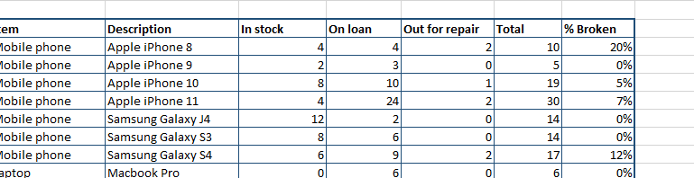

In this case, we used the standard All Borders setting for the entire table and set Thick Outside Borders around the edge.

Please save this spreadsheet once you have completed this exercise, as you will be using it again to practice other formulas in a later module.

Module 35 – Conditional Formatting

Open the Dates and Numbers spreadsheet you last used in Module 33.
Use what you have learned in this module about conditional formatting to create two new rules:
- For the Random Numbers column, create a rule whereby cells with a value of over 555 Euros are formatted to have dark red text and light red fill.
- For the Month formula column, create a rule whereby cells which contain the value ‘2’ have orange fill.
- For the Year column, apply one of the Color Scales formatting options from the Conditional Formatting menu.
This should give you some idea of the kinds of things you can achieve with conditional formatting. Feel free to experiment and make other changes.

Please save this spreadsheet once you have completed this exercise, as you will be using it again to practice other formulas in a later module.

Module 36 – Comments

Open the Inventory spreadsheet you last used in Module 34 and select the ‘Stock’ tab.

Your manager has requested that the reference numbers for mobile phone and laptop repairs are included in this inventory, to make it easier for people to check their status when calling the repair company.
Go to the Out for repair column. Wherever there’s a number in this column, add a comment with a reference number. Use these numbers, or make up your own:

- Reference RR4267PYN
- Reference RR349JHN
- Reference RR698FDR
- Reference RR801PVY
- Reference RR156PLI
- Reference RR466FCM

The Apple iPhone 10 which was out for repair has been returned. Update the inventory by performing these actions:
- Change the number of Apple iPhone 10s in stock to 9.
- Change the number of Apple iPhone 10s out for repair to 0.
- Delete the comment you created with the reference number for this item.

You have now completed the Microsoft Excel for Beginners course. Well done!

